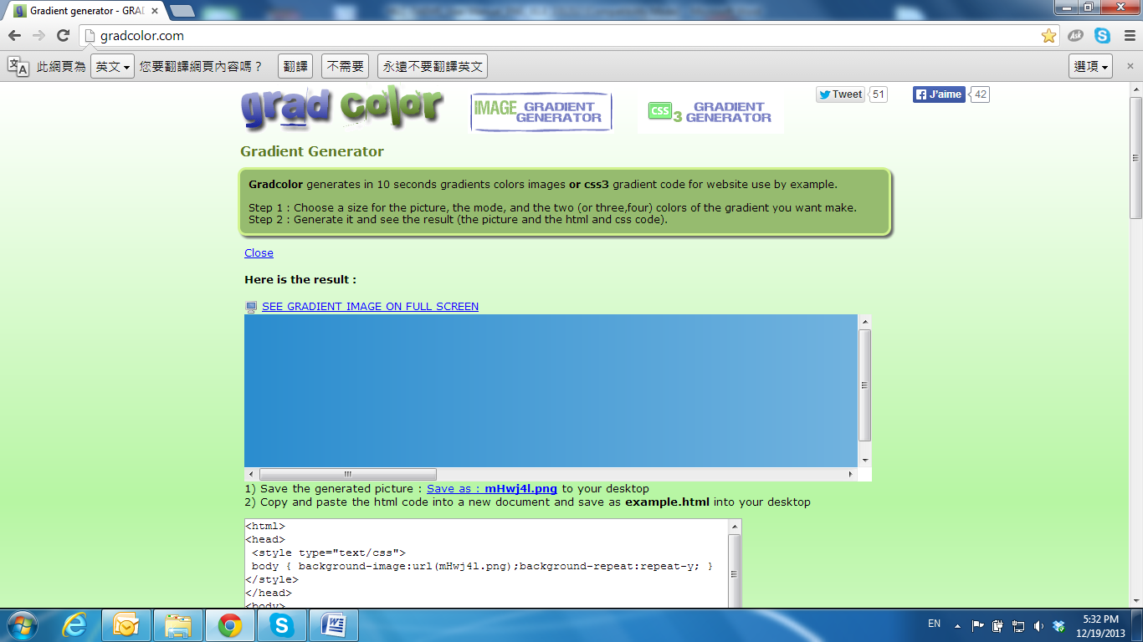

Factory Default

If you forget your password, please follow the steps to set back the IP Camera to its default value.

• Remove the power and Ethernet cable. Open the dome and press and hold the button as shown in the picture below.

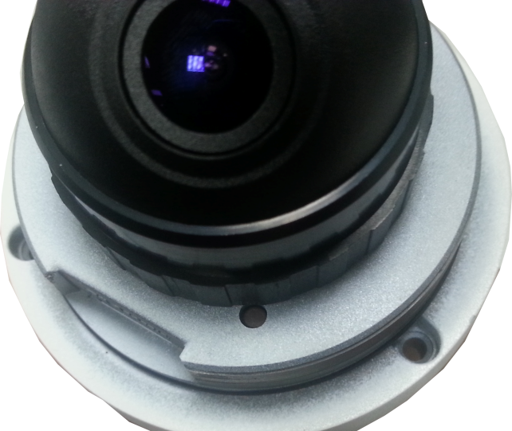

• Connect the power back to the camera, and do not release the button during the system booting. It will take around 30 seconds to boot the camera.

• Release the button when the camera finishes booting.

• Plug-in the Ethernet cable. Re-login the camera using the default IP

(**http://192.168.1.200**), and user name: **admin**, password: **admin**.